API HTTP Method

🌐 What is an API HTTP Method
# Source: AI Source: Provided by: [Data Path: Persons Table -> ID Column: 1, Name_En Column: Motasem Essam] -> From: [ChatGPT] on [1/19/2026]
An API HTTP Method is the type of action a client wants to perform on an API resource. These methods define what to do with the resource at the API endpoint.
👉 Think of HTTP methods as verbs describing what you want to do with a resource.

🔑 Common HTTP Methods
# Source: AI Source: Provided by: [Data Path: Persons Table -> ID Column: 1, Name_En Column: Motasem Essam] -> From: [ChatGPT] on [1/19/2026]
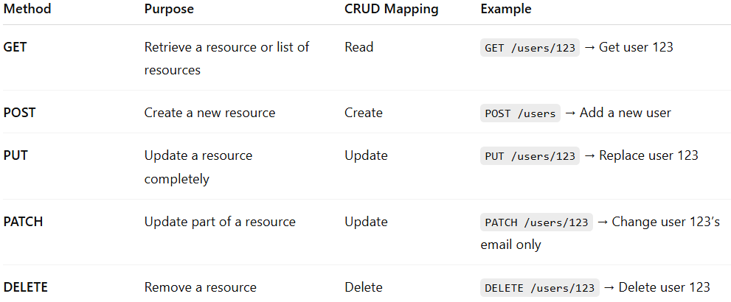
Method | Purpose | CRUD Mapping | Example
GET | Retrieve a resource or list of resources | Read | GET /users/123 → Get user 123
POST | Create a new resource | Create | POST /users → Add a new user
PUT | Update a resource completely | Update | PUT /users/123 → Replace user 123
PATCH | Update part of a resource | Update | PATCH /users/123 → Change user 123’s email only
DELETE | Remove a resource | Delete | DELETE /users/123 → Delete user 123

🧱 Example: User Resource

1️⃣ GET – Retrieve User
# Source: AI Source: Provided by: [Data Path: Persons Table -> ID Column: 1, Name_En Column: Motasem Essam] -> From: [ChatGPT] on [1/19/2026]
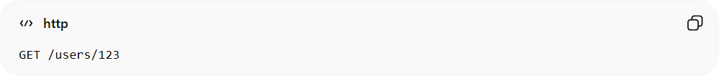
GET /users/123
Response:
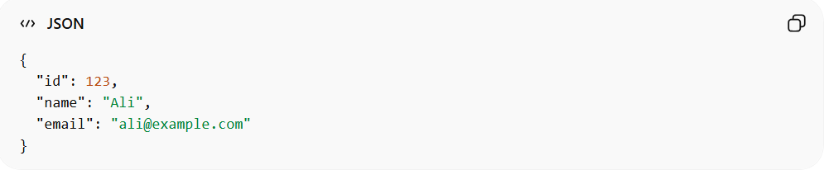
{
"id": 123,
"name": "Ali",
"email": "ali@example.com"
}

2️⃣ POST – Create User
# Source: AI Source: Provided by: [Data Path: Persons Table -> ID Column: 1, Name_En Column: Motasem Essam] -> From: [ChatGPT] on [1/19/2026]
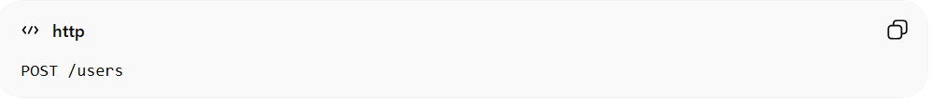
POST /users
Request body:
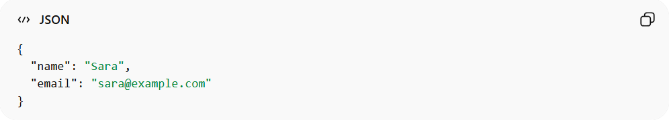
{
"name": "Sara",
"email": "sara@example.com"
}
Response: 201 Created

3️⃣ PATCH – Update User Email
# Source: AI Source: Provided by: [Data Path: Persons Table -> ID Column: 1, Name_En Column: Motasem Essam] -> From: [ChatGPT] on [1/19/2026]
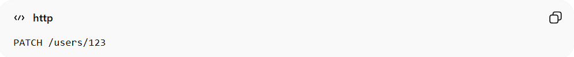
PATCH /users/123
Request body:
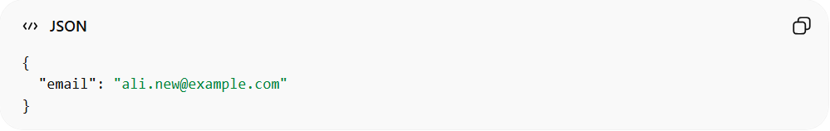
{
"email": "ali.new@example.com"
}
Response: 200 OK

4️⃣ DELETE – Remove User
# Source: AI Source: Provided by: [Data Path: Persons Table -> ID Column: 1, Name_En Column: Motasem Essam] -> From: [ChatGPT] on [1/19/2026]
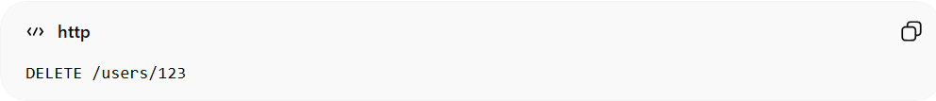
DELETE /users/123
Response: 204 No Content

❌ Common Mistakes
# Source: AI Source: Provided by: [Data Path: Persons Table -> ID Column: 1, Name_En Column: Motasem Essam] -> From: [ChatGPT] on [1/19/2026]
- Using GET for actions that modify data ❌
- Using POST to update existing resources instead of PUT/PATCH ❌
- Not following RESTful conventions ❌

💡 Summary
# Source: AI Source: Provided by: [Data Path: Persons Table -> ID Column: 1, Name_En Column: Motasem Essam] -> From: [ChatGPT] on [1/19/2026]
HTTP methods define what action is being performed on a resource.
GET = read, POST = create, PUT/PATCH = update, DELETE = remove

